Voice Banking System

Quick Summary
User speaks → Speech to text → Voice verification → Language detection & translation → Intent understanding → Bank API call → Spoken response
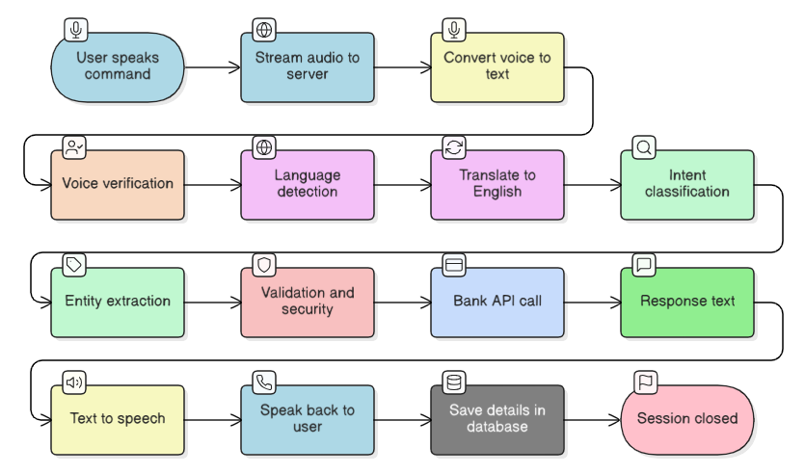

Process Flow

Step 1: Voice Input (User Speaks)
Phone or web app records voice and sends it to the server in real-time using WebRTC (a technology for live audio streaming).
- Session record in database (PostgreSQL) with status "session started"
- Audio chunks saved to object storage (S3)
- Database stores the file location (URI)

Step 2: Speech-to-Text Conversion (Whisper)
The Whisper speech recognition model converts spoken words into written text (e.g., "transfer five thousand rupees").
- Final transcript text
- ASR (Automatic Speech Recognition) confidence score
- Stored in PostgreSQL asr_segment table

Step 3: Voice Verification (SpeechBrain) - Optional
The system confirms the speaker's identity by comparing their voice to their enrolled voice profile using the SpeechBrain ECAPA-TDNN model.
- Verification score (0.0 to 1.0)
- Decision (accept/reject)
- Stored in speaker_verify_attempt table
Thresholds (starting recommendations):
- ≥ 0.80: Accept immediately
- 0.70-0.80: Soft accept, ask additional security question
- < 0.70: Reject, require alternative authentication

Step 4: Language Detection (AI4Bharat)
Identifies which language was spoken (e.g., Hindi, English, Tamil).
- Detected language code
- Confidence score
- Stored in NLU (Natural Language Understanding) record

Step 5: Language Translation (AI4Bharat IndicTrans2)
Only if the user spoke in a non-English Indic language.
- Translated English text
- Original language text (for audit trail)

Step 6: Intent Classification (Indic-BERT)
The NLU model analyzes the text and determines what the user wants to do.
- Predicted intent name
- Confidence score
- Stored in nlu_result table
Examples:
- "Show my transactions for last month" → Intent: GetTransactionHistory
- "Transfer money to John" → Intent: FundTransfer
- "What's my balance?" → Intent: CheckBalance
Confidence thresholds:
- ≥ 0.85: Proceed confidently
- 0.60-0.85: Ask clarifying question
- < 0.60: Request user to repeat or manual review

Step 7: Entity/Slot Extraction
Extracts specific important details from the sentence:
- Each extracted entity with its type
- Normalized form (e.g., "5000" from "five thousand")
- Confidence score
- Stored in nlu_entity table
Example:
- Amount: ₹5,000
- Person name: "John"
- Time period: "last month"
- Account number: last 4 digits
- Date/Time references

Step 8: Validation & Security Checks
Validation: (Stored in audit log)
- Is the amount numeric and positive?
- Is the account number format valid?
- Are required entities present?
Business rules:
- Does user have sufficient balance?
- Is amount within transaction limits?

Step 9: Bank API Call
If all checks pass, the system calls the bank's backend API to execute the requested action.
API inputs:
- User ID
- Transaction amount
- Destination account
- Session/audit IDs
- Authentication tokens
Examples:
- Retrieve last N transactions
- Execute fund transfer
- Get current balance
- Generate statement

Step 10: Text-to-Speech Response (TTS)
Converts the system's text response into natural speech and plays it back to the user.
Example responses:
- "Your transfer of ₹5,000 was successful. Reference number TXN1234."
- "Your current balance is ₹45,230."
- "I found 8 transactions in the last month."
Voice options:
- Generic TTS voice (faster, always available)
- User's cloned voice (if they opted in for personalization)
- Response text
- Audio file location (optional)
- TTS model used

Session Closure & Data Persistence
- Concatenate all audio chunks into complete recording
- Ensure all transcripts and NLU results are saved
- Store model versions used for each step
- Close session entry with final status
- Complete audit trail ready for compliance review

Starting thresholds that can be used

ASR (Speech Recognition)
- Minimum confidence: 0.60
- Below this: Ask user to repeat

Intent Classification
- High confidence: ≥ 0.85 (proceed)
- Medium confidence: 0.60-0.85 (ask clarification)
- Low confidence: < 0.60 (repeat or manual review)

Speaker Verification
- Strong match: ≥ 0.80 (accept)
- Moderate match: 0.70-0.80 (additional question)
- Poor match: < 0.70 (reject, require other auth)

